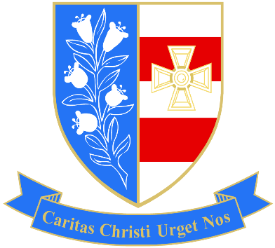

Hair and Beauty Scheduled Exams

Day | Start | Assessment | Duration (mins) | Room
Weds | 24/04/2024 13:00 | UB200B4 - Provide Facial Skin Care Treatments, Paper 1 | 60 | D102
Weds | 24/04/2024 14:00 | UB200N2 - Provide Manicure Services, Paper 1 | 60 | D102
Weds | 24/04/2024 15:00 | UB200B5 - Enhance the Appearance of Eyebrows and Eyelashes | 60 | D102
Tues | 30/04/2024 13.00 | UN2GH10 - Style and Finish Hair | 45 | D001
Tues | 30/04/2024 13.45 | UN2GH11 - Set and Dress Hair | 30 | D001
Tues | 30/04/2024 14.15 | UN2GH13 - Plait and Twist Hair | 30 | D001
Weds | 01/05/2024 14:00 | UB200N2 - Provide Manicure Services, Paper 2 | 75 | D002
Weds | 01/05/2024 15:00 | UB200N3 - Provide Pedicure Services, Paper 2 | 75 | D002
Tues | 07/05/2024 13:00 | UN20GH9 - Change Hair Colour | 120 | D105
Tues | 07/05/2024 15:00 | UN20GH8 - Shampoo, Condition and Treat the Hair and Scalp | 75 | D105
Weds | 08/05/2024 13:00 | UB200B4 - Provide Facial Skin Care Treatments A&P, Paper 2 | 105 | D002
Weds | 15/05/2024 14:00 | UB200B6 - Carry Out Waxing Services, Paper 1 | 60 | D002
Weds | 15/05/2024 15:00 | UB200B6 - Carry Out Waxing Services, Paper 2 | 60 | D002
Weds | 22/05/2024 13:00 | UB200B8 - Provide Make-Up Services, Paper 1 | 60 | D002
Weds | 22/05/2024 14:00 | UB200B8 - Provide Make-up Services, Paper 2 | 45 | D002

