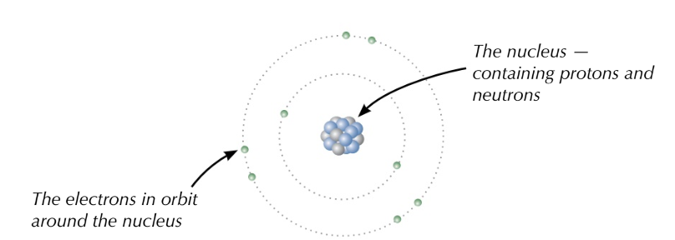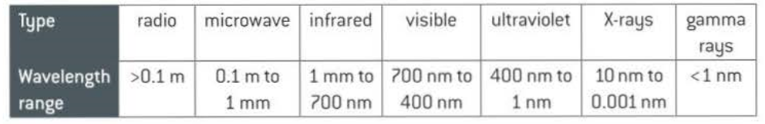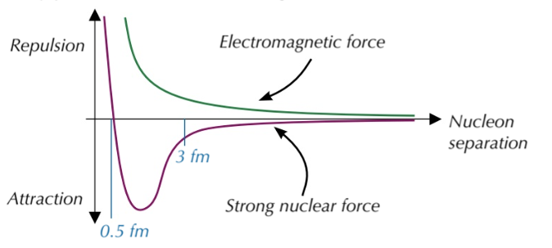

Particles and photons

**Electromagnetic radiation travels in packets or quanta called ​photons​, which transfer energy and have no mass. The energy of photons is directly proportional to the frequency:**

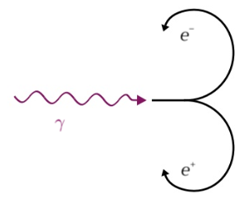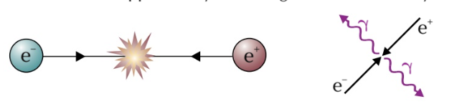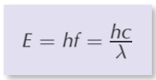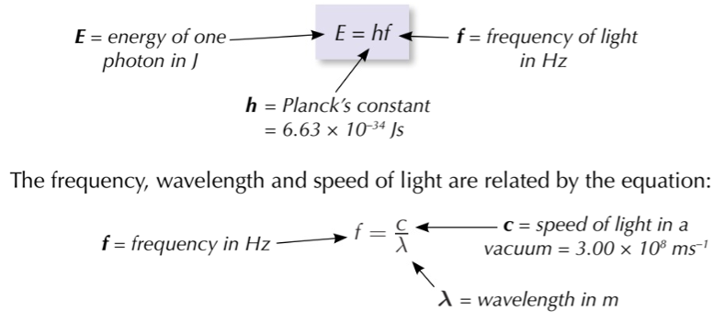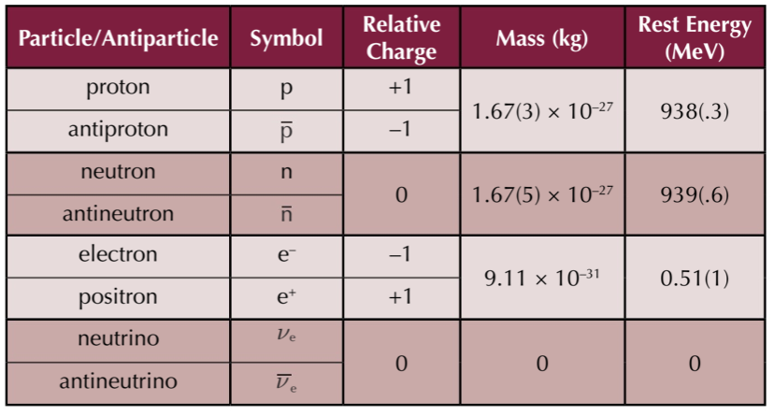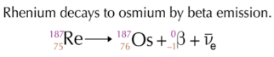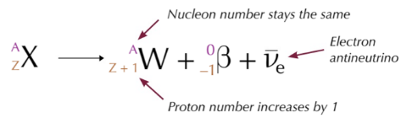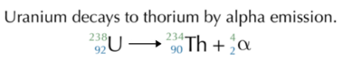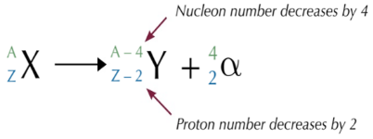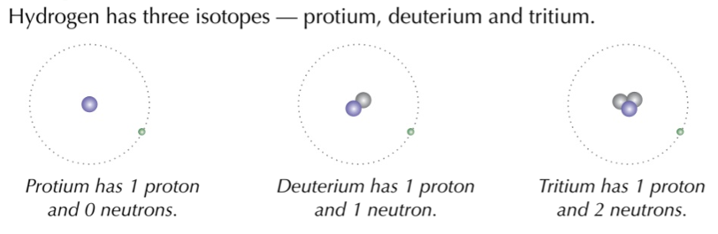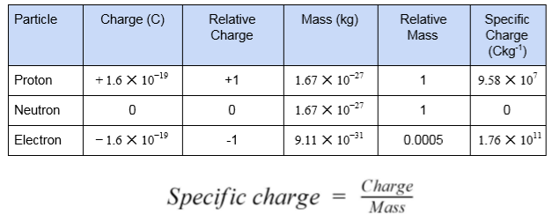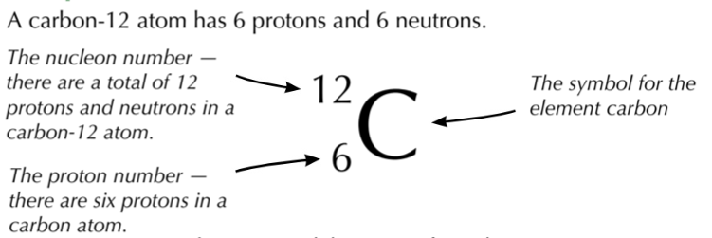

**Pair production ​is where a photon is converted into an equal amount of matter and antimatter.**

**Annihilation ​is where a particle and its corresponding antiparticle collide, as a result their masses are converted into energy**

**The ​strong nuclear force (SNF)​ keeps nuclei stable by counteracting the electrostatic force of repulsion between protons in the nucleus.**

**It only acts on nucleons and has a very short range; It is attractive up to separations of 3 fm (3 x 10-15m) It is repulsive below separations of 0.5 fm**

**For every type of particle there is an ​antiparticle​ which has the ​same rest energy and mass but opposite charge**

**When a nucleus with ​too many of either protons, neutrons the SNF is not be enough to keep them stable, therefore these nuclei will decay in order to become stable.**

**Isotopes ​are ​atoms with the same number of protons but different numbers of neutrons**

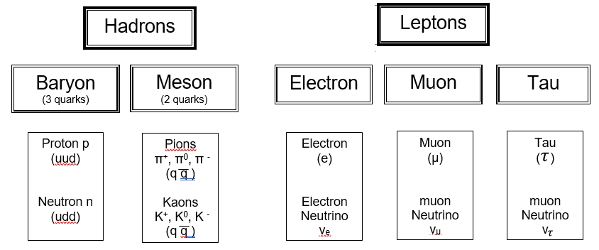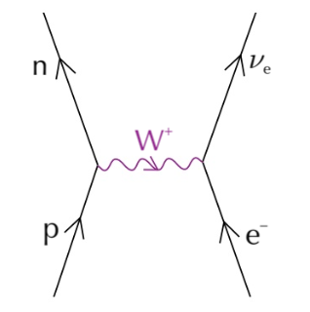

**The standard model**

**Electron capture**

An orbiting electron gets dragged into the nucleus

**There are four fundamental forces: ​gravity, electromagnetic, weak nuclear and strong nuclear​.**

Particles and interactions

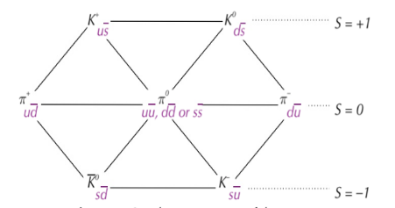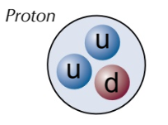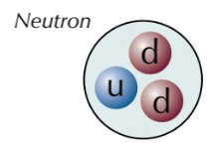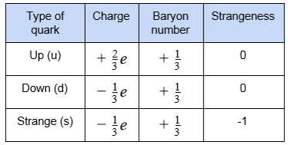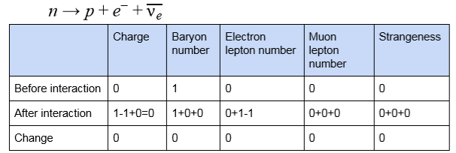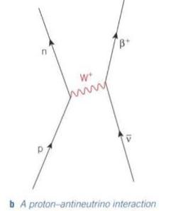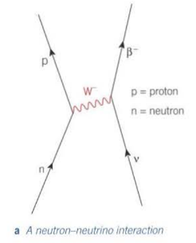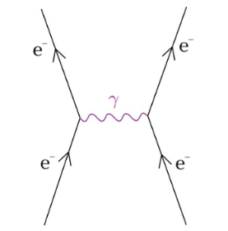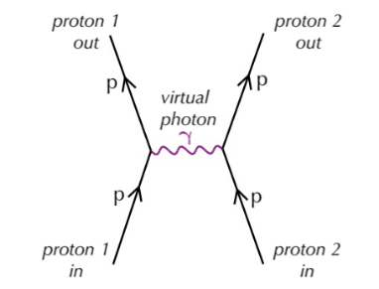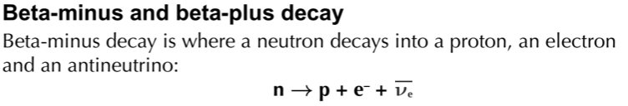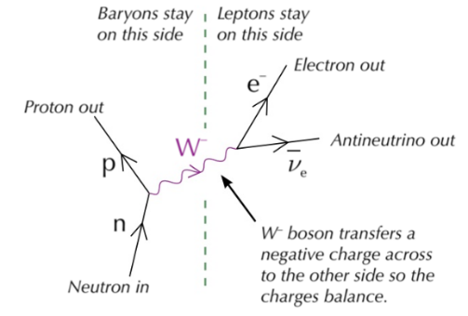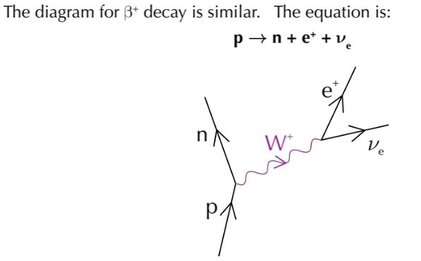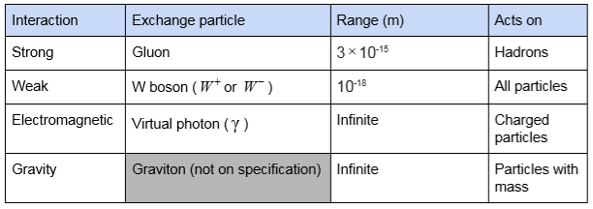

**Electromagnetic repulsion**

Objects of the same charge repel each other

**​Strange particles​ are particles which are ​produced by the strong nuclear interaction but decay by the weak interaction​. kaons, which decay into pions, through the weak interaction contain strange quarks. Strange particles must be created in pairs.**

**Quark configurations in baryons and mesons**

**Types of quark**

**​Conservation rules:**

**These properties ​must always be conserved​ in particle interactions:**

**Charge, Baryon number, Lepton number, Strangeness Also, Energy, mass, momentum**

**Other common interactions**

**​Feynman diagram explain particle interactions**

**​Exchange particles​ carry energy and momentum between the particles experiencing the force, each fundamental force has its own exchange particle**

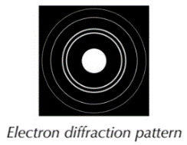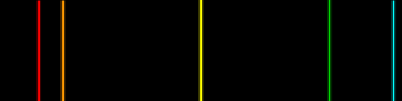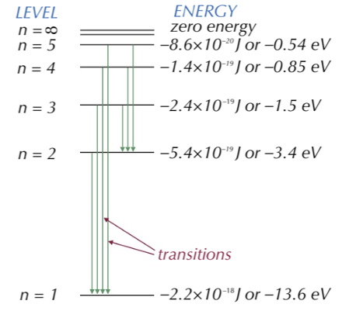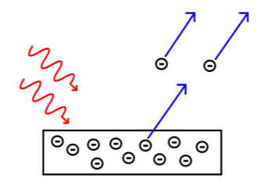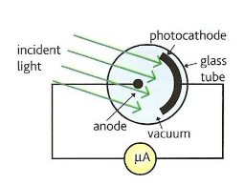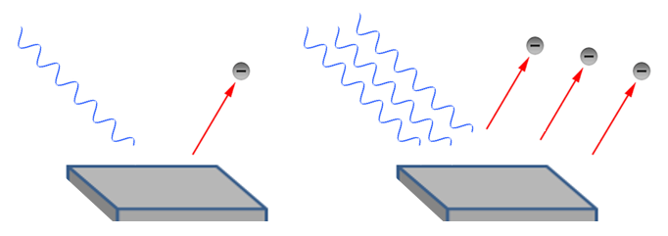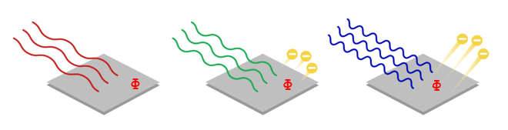

**Particles such as electrons can also be shown to have wave properties (like diffraction). This is achieved by accelerating them to very high speeds. It is called the De Broglie wavelength:**

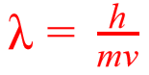

**An example of a practical use of excitation is a fluorescent tube in order to produce light**

**An electron excited up to n=5 from n=1 needs to gain exactly 13.6 – 0.85 = 12.75eV of energy. The electron can drop down in many different jumps as shown, each emitting a different photon. When these are in the visible range, they create a unique line spectrum pattern for that atom**

**Electrons in atoms can only exist in ​discrete energy levels​. They can move up levels by gaining energy equal to the exact difference between levels. The are said to be excited. When electrons drop down or de-excite they release the energy again in the form of photons.**

EM radiation and quantum phenomena

**The electron volt (eV) is a measure of energy often used on the small scale. You are often required to convert between eV and J:**

**eV to joules, multiply your value by 1.6 × 10-19 joules to eV, divide your value by 1.6 × 10-19**

**The ​photoelectric effect​ is where photoelectrons are emitted from the surface of a metal after light above a certain frequency is shone on it. This certain frequency is different for different types of metals and is called the ​threshold frequency, fo​.**

**The ​work function Φ ​ of a metal is the minimum energy required for electrons to be emitted from the surface of a metal.**

**photoelectric equation is:**

**Ein = Φ + Ek (max)**

**Or**

**hfin =hfo + ½ mv2**

**Explaining the equation… A single ​photon of energy in (hfin) strikes a single electron. If this photon has a frequency above the threshold frequency (fo) the minimum energy or work function (hfo) is achieved and the electron will leave the surface. Any excess energy will give the electron kinetic energy. (Ek  = ½ mv2)**

**If a potential difference equal to the Ek of the electrons is applied to the surface of the metal the flow of photoelectrons can be stopped. This stopping potential is given by:**

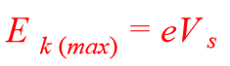

**Where Vs is the stopping potential and e is the charge on an electron**

**A photocell can be used to demonstrate the effect. The ammeter measures a current which is proportional to the number of electrons emitted Increases the number of photoelectrons BUT does not increase their kinetic energy**

**Increasing the intensity…. Increases the number of photoelectrons BUT does not increase their kinetic energy**

**Increasing the frequency…. Increases the average kinetic energy of the photoelectrons**

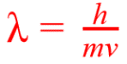

**Particles such as electrons were traditionally thought of as discrete pieces of matter. We can however show that they can have wave-like properties under certain conditions.**

**This is achieved by accelerating them to very high speeds and firing them at thin sheets of material, such as graphite.**

**The electrons produce a diffraction pattern as shown opposite as if they were a wave.**

**The spacing of the rings is determined by the speed of the particle and so De Broglie suggested that the particles exhibit a wavelength. When the speed (momentum) is increased, the wavelength will decrease, and therefore the amount of diffraction decreases, so the concentric rings of the interference pattern become closer. Whereas, when momentum is decreased, the wavelength increases,**

**the amount of diffraction increases so the rings move further apart. De Broglie came up with the formula sown to calculate**

**the effective wavelength**

**In many instances, light behaves light a wave. Light reflects, refracts and diffracts in the same way that wave waves and sound wave do.**

**We need to think of waves as particles to explain the photo-electric effect. Here the incoming light is in the form of ‘packets’ or particles of energy which we now call photons.**

**The energy of a photon cannot be split up and is determined by the frequency of the photon**

**Electrons in atoms can gain energy from photons AND also from collisions**

**with electrons, to become excited. When they drop back down they de-excite and release energy equal to the difference in energy levels as shown below.**

**Unlike photons, the incoming electron can give up some of its energy, so does not have a need to have the exact energy to cause a jump as photons do.**

**Fluorescent tubes are one practical use of excitation. The process is:**

* **A high voltage accelerates free electrons through the tube**
* **These electrons collide with the atoms of mercury vapour and excites electrons**
* **Mercury electrons de-excite releasing photons in the UV range**
* **These UV photons strike the phosphor coating of the glass walls of the tube**
* **This causes a second excitation and when the phosphor electrons de-excite, visible light is emitted**

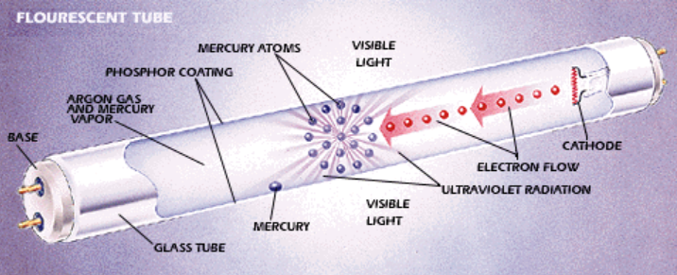

Collisions of electrons with atoms and wave particle duality

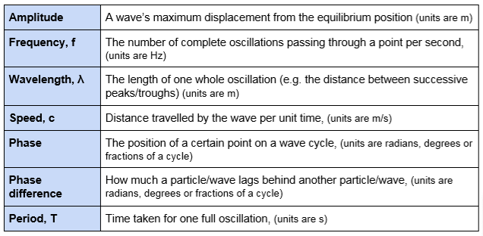

**A ​stationary wave​ is formed from the ​superposition of 2 progressive waves​, travelling in opposite directions ​in the same plane, with the ​same​ ​frequency, wavelength and amplitude.**

**No energy is transferred by a stationary wave​.**

**​**

**Polarised waves​ ​oscillate in only one plane ​only transverse waves can be polarised, longitudinal cannot. Uses: sunglasses and TV broadcasts**

Waves

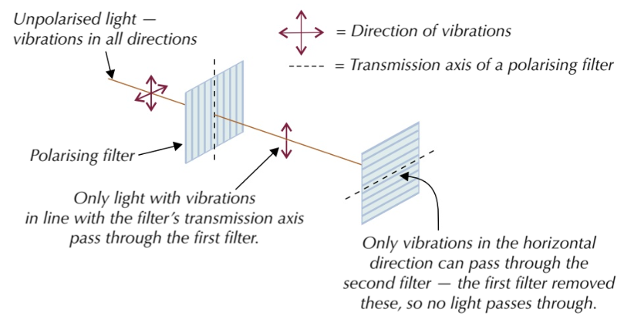

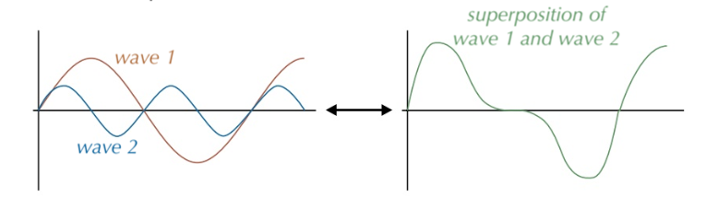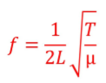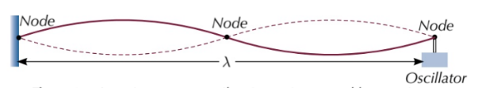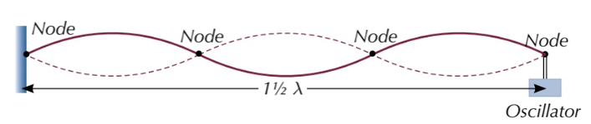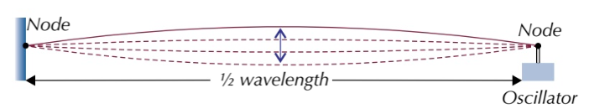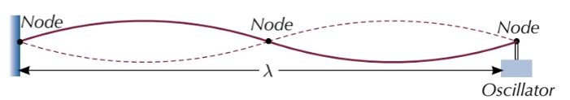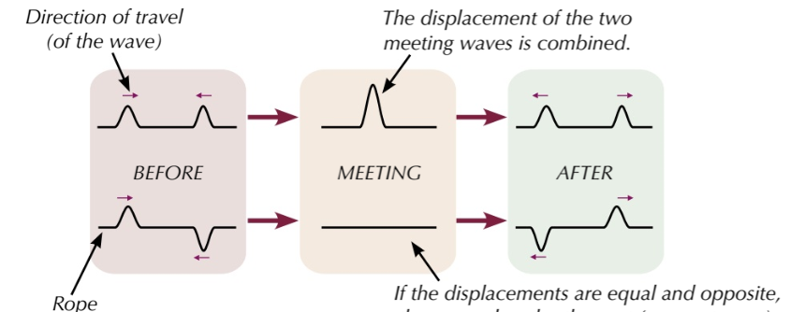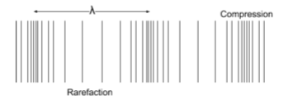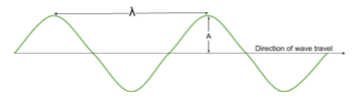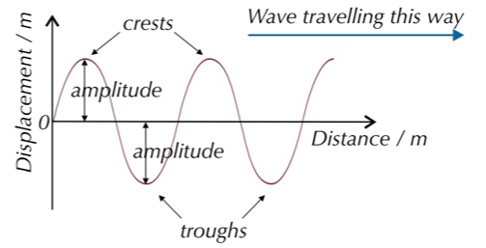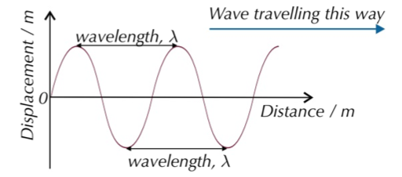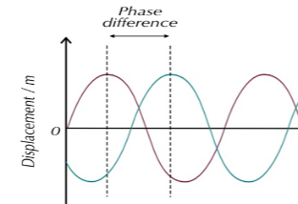

Antinode

**Constructive Superposition: The resultant amplitude is larger due to amplitudes adding**

**Destructive Superposition: The resultant amplitude is smaller (or zero) as amplitudes cancel each other.**

**​**

**This equation can be used to determine the frequency of harmonics:**

**By changing the frequency of vibration on a fixed**

**length of string, various resonant frequencies are**

**seen, each producing a standing wave. These are known as harmonics**

Antinode

**Nodes are points of no movement**

**Antinodes are points of maximum amplitude**

**All points in one ‘loop’ oscillate in phase**

**All points in adjacent loops are in anti-phase**

3nd harmonic

2nd harmonic

1st harmonic

**Superposition: When two waves combine as they pass each other. The resultant displacement is the ​vector sum​ of each wave’s displacement.**

**​ ​**

Longitudinal

Transverse

vibration direction

Wave direction

**Transverse waves​ - oscillation of particles (or fields) is at​ right angles to the direction of energy transfer.**

**e.g. water waves and all e.m. waves.**

**Longitudinal waves -​ oscillation of particles is ​parallel to the direction of energy transfer e.g. sound**

**Wave speed is:**

**Frequency and time period:**

**Two points on a wave are ​in phase​ if they are both at the same point of the wave cycle, they will have the ​same displacement and velocity ​and their​ phase difference will be a multiple of 360° (2π radians)**

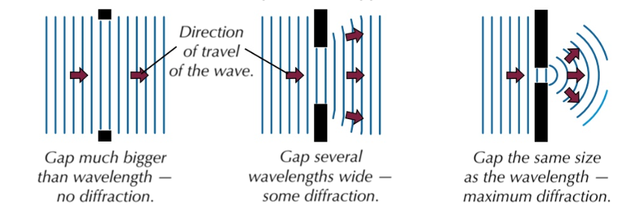

Diffraction and interference

**Path difference ​is the difference in the distance travelled by two waves. A ​coherent ​light source has the ​same ​frequency and wavelength​ and a ​fixed phase difference​.**

**A ​diffraction grating​ is a slide containing many ​equally spaced slits very close together. ​The interference pattern is much sharper and brighter ​than a double slit.**

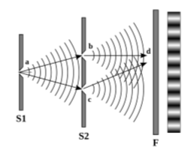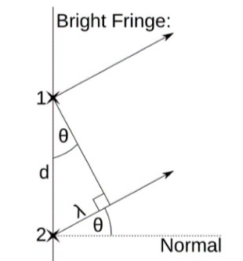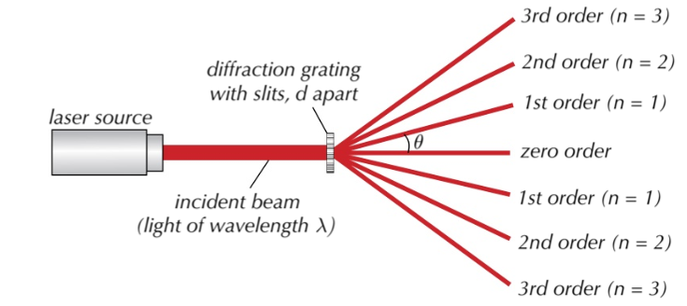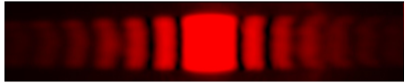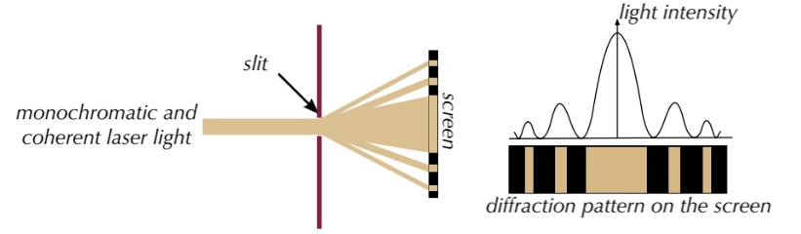

**Young’s double slit experiment​ demonstrates interference of light from two-sources. The single slit before the double slit to make the light have a fixed path difference and so gives coherence at the double slit. The filter makes the light monochromatic (single wavelength)**

**Young's double slit is evidence of light behaving as a wave as diffraction​ and ​interference​ occur**

**If ​white light​ is used you will see ​wider, lese intense maxima​. A ​central white fringe,​ other fringes, violet is closest to the centre, red furthest**

**Formula:**

**​w​ is the fringe spacing, λ​ is wavelength ​D​ is the distance between the screen and slits ​s​ is slit separation**



**Diffraction gratings can be used to analyse coloured light from stars which allows us to determine their composition**

**​We can prove the equations using trigonometry. For a bright fringe, the path difference between rays from adjacent slit needs to be a whole number of λ. For the 1st fringe n = 1. By looking at the diagram below, sinθ = λ/d. For the 2nd fringe path difference would be 2λ, so sinθ = 2λ/d. Rearranging gives 2λ = dsinθ, which is where nλ = dsinθ, comes from the nth bright fringe**

**​The formula associated with diffraction gratings is:**

**d is the distance between the slits θ is the angle to the normal made by the maximum n is the order and λ is the wavelength.**

**A wider ​slit gives narrower central maximum with increased intensity.**

**Increasing​ ​wavelength​ ​gives a wider central maximum of decreased intensity**

**White light produces a white central fringe with outer fringes showing the spectral colours in order, violet closet to the centre**

**With monochromatic light. The pattern is a bright double width central band. The alternate dark (due to destructive superposition) and bright (due to constructive superposition) fringes**

**Diffraction is the spreading out of waves as the pass through a gap or around an obstacle. Maximum diffraction occurs when gap = wavelength**

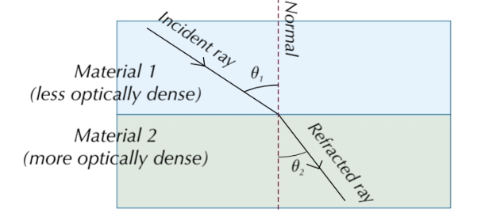

**​Optical fibres rely on TIR. They are flexible, thin tubes of plastic or glass which carry information in the form of light signals. They have an ​optically dense core​ surrounded by ​cladding​ with a lower optical density. The ​cladding​ also protects the core from damage​ and prevents ​​light escaping the core.**

**Refraction is the change of direction that occurs when light passes at an angle across a boundary between two transparent substances.**

**It bends towards the normal when it passes from less dense air to more dense glass (LMT). It bends away from the normal when it passes from glass back into air. (MLT). No refraction takes place if the incident light ray is along the normal.**

Refraction at a plane surface

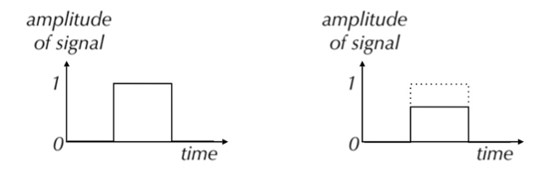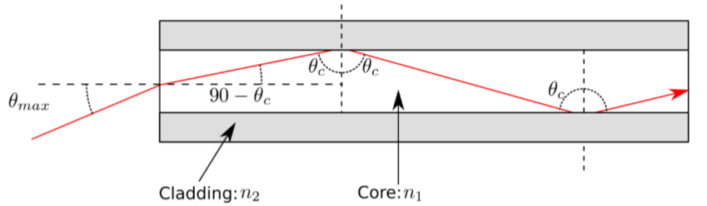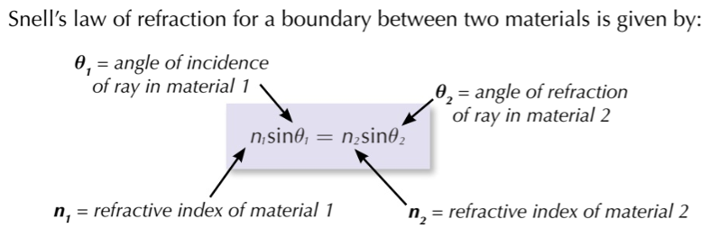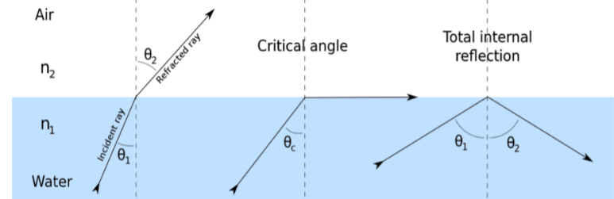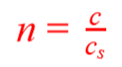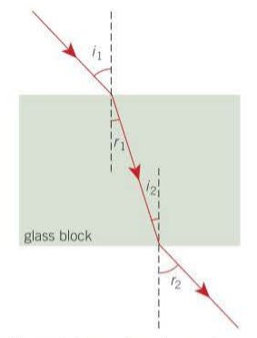

**​Signals sent along optic fibres can degrade for a number of reasons.**

1. **Absorption**

**The fibre absorbs some of the signal resulting is a reduction of amplitude**

1. **Dispersion (causing pulse widening)**

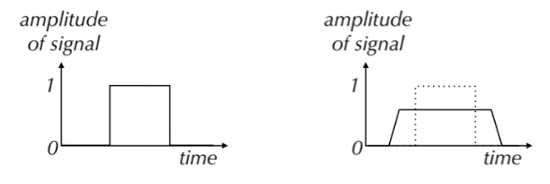

**a) Modal dispersion Caused by light entering the fibre at varying angles b) Material dispersion Different wavelengths refract by different amounts**

**Total internal reflection (TIR)​ is a special case of refraction within materials**

**In picture 1 normal refraction occurs when light travels from a more dense to a less dense material.**

**If angle θ1 is increased, θ2 increase also. Picture 2 shows the point when θ2, has become 900, so the refracted ray is along the boundary.**

**If θ2 is increased further then no refraction occurs and the light, is reflected back into the block as shown in picture 3. Normal reflection rules occur where θ1 = θ2**

**ilTotal internal reflection (TIR)​ is a special case of refraction within materials**

**The ​refractive index (n)​ is a property of a material which measures how much it slows down light passing through it. This is calculated by dividing the speed of light in a vacuum (c) by the speed of light in that substance (c​s​).**

**Refraction occurs to differences in optical density. Glass is more dense to light than air and so light slows down in glass causing a direction change.**