Unit 2

Fitness Training and Programming for Health, Sport and Well-being.

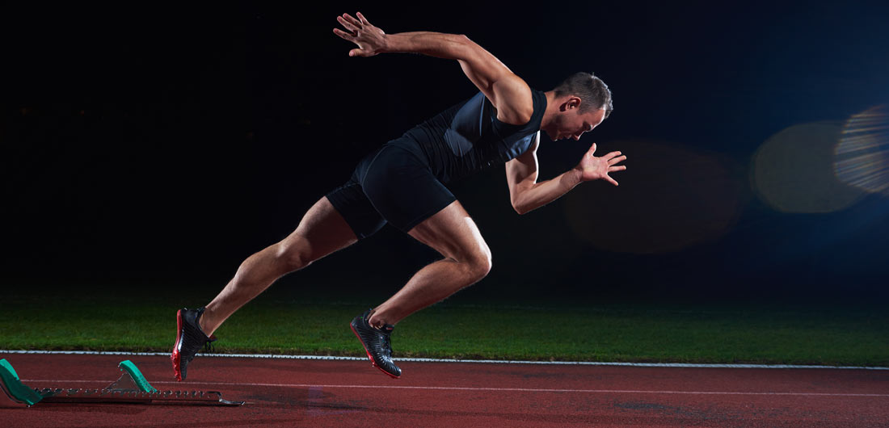

How you will be assessed

This unit will be assessed externally using an examination set by Pearson. The examination will contain two parts.
- Part A is supplied a set period of time before your examination so that you can carry out independent research about a scenario based on an individual who requires guidance on training, lifestyle and nutrition.
- Part B is a written examination under controlled conditions in which you can use your research notes to complete a task that builds on Part A.
Learning Aims

- Examine lifestyle factors and their effect on health and well-being.

- Understand the screening processes for training and programming.

- Understand programme related nutritional needs.

- Examine training methods for different components of fitness.

- Understand training programme design.

- Examine lifestyle factors and their effect on health and well-being.

Question

Paul is stressed on a daily basis because he has a demanding workload; he only allows himself an average of 6 hours of sleep per night.

- Compare this to the NHS recommendations for sleep.
___________________________________________________________________________________________________________________________________________________________________________________________________________________________

b) How might his sleep pattern cause him additional stress?
____________________________________________________________________________________________________________________________________________________________________________________________________________________________________________________________________________________________________

The majority of health concerns and cost for the NHS is because of the negative lifestyle some people lead- Discuss and write down,
- What do you think the term sedentary lifestyle means?
____________________________________________________________________________________________________________________________________________________________________________________________________________________________________________________________________________________________________
- What could happen to you if you lead a negative lifestyle and how could this become a burden on the NHS?
______________________________________________________________________________________________________________________________________________________________________________________________________________________________________________________________________________________________________________________________________________________________________________________________________________________________________________________

- Common barriers to change

Poor health is a drain on national resources and increases the amount spent on healthcare by the government. However, many people encounter difficulties in living a healthy lifestyle. Age, ethnicity and social and economic status may all present challenges to achieve wellness.
TIME, COST, TRANSPORT AND LOCATION are the most common barriers to change, write why you think these are the most common barriers when trying to lead a healthy lifestyle.
________________________________________________________________________________________________________________________________________________________________________________________________________________________________________________________________________________________________________________________________________________________________________________________________________________________________________________________________________________________________________________________________________________________________________________________________________________________________________________________________________________________________________________________________________________________________________________________________________________________________________________________________________________________________________________________________________________________________________________________________________________________________________________________________________________________________________________________________________________________________________________________________________________
A) Smoking
Smoking is a major health risk. It can cause heart disease, numerous cancers and bronchial disorders. Over 100,000 people die each year from smoking related diseases. According to the NHS, smoking increases a person’s risk of developing heart disease by 24%.The body becomes addicted to the nicotine in tobacco. Nicotine is a stimulant, which means that it makes the heart beat faster and narrows blood vessels.Smoking decreases lung capacity, which can have a serious effect on your fitness.
Research other negative health implications which are caused by smoking.
____________________________________________________________________________________________________________________________________________________________________________________________________________________________________________________________________________________________________________________________________________________________________________________________________________________________________________________________________________________________________________________________________________________________________________________________________________________________________________________________________________________________________________________________________________________________________________________________________________________________________________________________________________________________________________________________________________________________________________________________________________________________________________________________________________________________________________________________________________________________________________________________________________________________________________________________________________________________________________________________________________________________________________________________________________________________________________________________________________________________________________________
- Alcohol
Moderate alcohol consumption is thought to help reduce the risks of heart disease. However, too much alcohol can cause health problems such as malnutrition, cirrhosis of the liver, certain types of cancer and psychological health problems.
Research Health risks associated with excessive alcohol consumption.

Stroke | Hypertension
Cirrhosis | Depression

c) Micronutrients/macronutrients

Research what Micronutrients are and also Macronutrients, state how they help the body function.
TIPS-
Fats, protein, carbohydrates, vitamins and minerals
______________________________________________________________________________________________________________________________________________________________________________________________________________________________________________________________________________________________________________________________________________________________________________________________________________________________________________________________________________________________________________________________________________________________________________________________________________________________________________________________________________________________________________________________________________________________________________________________________________________________________________________________________________________________________________________________________________________________________________________________________________________________________________________________________________________________________________________________________________________________________________________________________________________________________________________________________________________________________________________________________________________________________________________________________________________________________________________________________________________________________________________________________________________________________________________________________________________________________________________________________________________________________________________________________________________________________________________________________________________________________________________________________________________________________________________________________________________________________________________________________________________________________________________________________________________________________________________________________________________________________________________________________________________________________________________________________________

Types of Aerobic training-Continuous training
Also known as steady-state or long, slow distance training: the athlete trains at a steady pace over a long distance. The intensity of continuous training should be moderate (approximately equal to or less than 70% of VO2 Max) over a long distance and time.
This method is suited to long distance runners and swimmers. Due to the lower level of intensity, an athlete can train for longer . It can also be useful for-
- Beginners who are starting structured exercise
- Athletes recovering from injury
- ‘Specific population’ individuals such as children or elderly people.
What are the disadvantages continuous training can have and where can continuous training take place?
- Higher risk of injury when running long distances on hard surfaces.
- Boring
- Not always sports specific
Continuous training can be performed in a gym using a range of cardiovascular equipment (For example, treadmill, cross-trainer) or outdoors at a suitable park or track area.
Research task
Research what Fartlek, Interval and Circuit training are and write about the benefits of each and which sports will benefit from these training methods.
_______________________________________________________________________________________________________________________________________________________________________________________________________________________________________________________________________________________________________________________________________________________________________________________________________________________________________________________________________________________________________________________________________________________________________________________________________________________________________________________________________________________________________________________________________________________________________________________________________________________________________________________________________________________________________________________________________________________________________________________________________________________________________________________________________________________________________________________________________
_____________________________________________________________________________________________________________________________________________________________________________________________________________________________________________________________________________________________________________________________________________________________________________________________________________________________________________________________________________________________________________________________________________________________________________________________________________________________________________________________________________________________________________________________________________________________________________________________________________________________________________________________________________________________________________________________________________________________________________________________________________________________________________________________________________________________________________________________________________________________________________________________________________________________________________________________________________________________________________________________________________________________________________________________________________________________________________________________________________________________________________________________________________________________________________________________________________________________________________________________________________________________________________________________________________________________________________________________________________________________________________________________________________________________________________________________________________________________________________________________________________________________________________________________________________________________________________________________________________________________________________________________________________________________________________________________________________________________________________________________________________________________________________________________________________________________________________________________________________________________________________________________________________________________________________________________________________________________________________________________________________________________________________________________________________________________________________________________________________________________________________________________________________________________________________________________________________________________________________________________________________________________________________________________________________________________________________________________________________________________________________________________________________________________________________________________________________________________________________________________________________________________________________________________________________________

