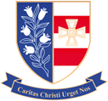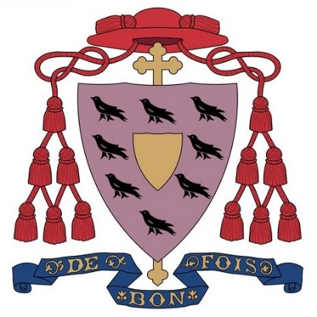
St Joseph’s Catholic Academy

Summer School 2021 Statement

During the 2021 summer holidays, the pupils entering Year 7 in September 2021 were invited to attend the academy’s Summer School. Over the course of 5 days, pupils engaged in a number of carefully planned activities designed to support them in transitioning to Secondary School, allowing them to familiarise themselves with the school environment and the staff who will support them from September 2021, and to allow ‘catch-up’ activities particularly in English, Maths and Science.
Pupils took part in a wide range of activities including; First aid training, Ukulele lessons, Duke of Edinburgh taster sessions, robot building and programming and Spiritual mission events. In delivering these activities, the academy was supported by a range of qualified teaching staff and support staff including the SENCO and first aider.

Funding breakdown
Summer school grant allocation | £30805.2
Staffing costs | £17,211.43
Catering costs | £786.65
Resources* | £1267.86
Total expenditure | £19265.94

*Resources includes both physical resources purchased to facilitate the summer school sessions, and the costs associated with 3rd party providers who were engaged to facilitate sessions.

