Young business owner honoured by the Queen for pandemic work overwhelmed by local support

A young business owner who helped thousands of NHS staff at the height of the coronavirus pandemic has spoken of his shock after he was honoured by the Queen.
By Ryan Smith
Saturday, 24th October 2020, 2:57 pm
Josh Trueman, a business owner from Jarrow, has so far made more than 20,000 face mask clips and 150 protective screens throughout the Covid-19 outbreak.
The 21-year-old produced the clips, nicknamed ‘ear savers’ for NHS staff in hospitals across the country and was included in the Queen’s Birthday Honour’s List for his efforts.
Josh, who runs the laser cutting and engraving business, JT Workshop, has told the Gazette about the moment he found out that he had made it onto the list.
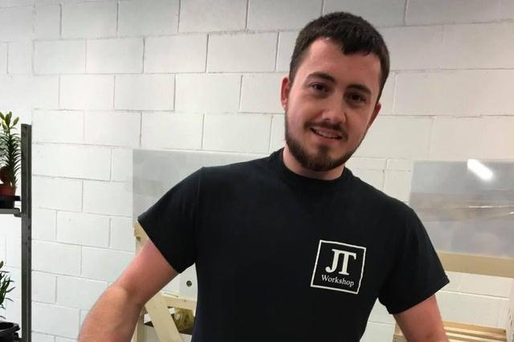Josh Trueman has so far made over 20,000 "ear saver" face mask clips for NHS staff and was honoured by the Queen for his efforts.
He said: “I received a letter about a month before it was all official. My mam rang me while I was at work to say there was a letter for me in the house which is strange because I always have my post delivered to my unit.
"She brought it down for me and when I opened it, I was just in shock. I showed my mam and she was exactly the same, it was really nice to receive it.
"You don’t really expect something like that to come in the post and it took a few days to sink in, my whole family are proud of me.”
Despite the honour, it has been the positive feedback closer to home which has effected Josh the most.
He added: “Throughout the whole pandemic we’ve worked to make the lives of NHS staff easier, we’ve donated to local food banks, helped them source toilet rolls, basically anything we could do to help, we did it.
"I’ve had so many people message to say thanks for everything I’ve done, a lady came the other day to pick up some face mask clips and she broke down in tears when thanking me for all the help.
"Some people sent me photos of the sores on their ears that the masks were leaving so I’m glad it made their lives easier.

