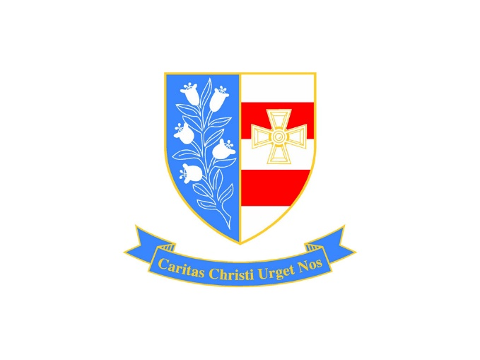

School Uniform Policy
September 2023

Approved by: | Local Governing Body | Date: July 2023
Last reviewed on: | July 2023
Next review due by: | July 2024

Overview
The school has used the DfE non-statutory guidance on school uniform and agrees with guidance given in the DfE booklet which states;

‘The school uniform plays a valuable role in contributing to the ethos of a school and setting an appropriate tone. The Department strongly encourages schools to have a uniform as it can instil pride; support positive behaviour and discipline; encourage identity with, and support for, school ethos; ensure pupils of all races and backgrounds feel welcome; protect children from social pressures to dress in a particular way; and nurture cohesion and promote good relations between different groups of pupils. The Department also encourages schools to have a very clear position about appearance such as hair colour, style and length and the wearing of jewellery and makeup.’

The school therefore expects high standards of personal appearance and that all students should wear school uniform to and from school, during the school day or when participating in school-organised events.

Our school has a duty to make sure that the uniform we require is affordable, in line with statutory guidance from the Department for Education on the cost of school uniform.
We understand that items with distinctive characteristics (such as branded items, or items that have to have a school logo or a unique fabric/colour/design) cannot be purchased from a wide range of retailers and that requiring many such items limits parents’ ability to ‘shop around’ for a low price.
We will make sure our uniform:
- Is available at a reasonable cost
- Provides the best value for money for parents/carers
We will do this by:
- Carefully considering whether any items with distinctive characteristics are necessary
- Limiting items with distinctive characteristics to low-cost or long-lasting items
- Avoiding specific requirements for items pupils could wear on non-school days, such as coats, bags and shoes
- Keeping the number of optional branded items to a minimum, so that the school’s uniform can act as a social leveller
- Avoiding different uniform requirements for different year/class/house groups
- Avoiding different uniform requirements for extra-curricular activities
- Making sure that arrangements are in place for parents to acquire second-hand uniform items
- Avoiding frequent changes to uniform specifications and minimising the financial impact on parents of any changes
- Consulting with parents and pupils on any proposed significant changes to the uniform policy and carefully considering any complaints about the policy

Expectations for School Uniform
Our school’s uniform
Uniform should comply with our clear uniform code at all times. This is because we want pupils at St Joseph’s Catholic Academy to be proud and to feel part of our community. The dress code applies both within school and on the journey to and from school. Fashion statements with regards to students’ dress or appearance are unacceptable. If in doubt, parents and carers should contact the school before any decisions are made.
Pupils must be dressed properly in full school uniform;
- Grey blazer branded with St Joseph’s Logo
- House colour ribbons should be worn on left chest pocket of the blazer (these will be provided by the school as part of the transition process)
- School Tie (blue and gold diagonal strip) fastened up to the neck properly and worn at a reasonable length
- A plain white shirt which buttons to the neck and is tucked in at all times
- Plain black formal school trousers
- A plain black drop-waisted skirt with box style pleats. Our expectation is that skirts are worn at knee length.
- Black opaque tights OR black /dark grey socks
- Plain black formal school shoes. We would also recommend that parents get their child shoes that will cover their whole foot for the extreme weather if they are walking to school in snow/ slush-type conditions.
- Outdoor coats should be dark in colour and fit for purpose
- School bag: Every pupil should have a bag to carry books, school planner and equipment to and from school every day and pupils should be properly equipped for every lesson
- Water bottle
Important notes
There are many items of clothing online and in school shops under school uniform that do not adhere to our policy.
- Trainers are not permitted. In extreme weather, stout footwear can be used, but they must be covered by trousers. Fashionable boots e.g. Ugg boots are not permitted.
- No denim-type material or jean style trousers. No ‘skinny fit’ trousers, lycra-type material or elasticated waists. No zipped pockets or gold/silver fashion accessories.
- Skirts must not have an elasticated waist. No lycra-type or pull on stretchy material skirts are allowed.
- No visible tops / shirts to be worn under the shirt. Plain white vests etc. are acceptable but brightly coloured undergarments are not.
- Haircuts which are extreme, or unnatural or hair dye are not permitted. No lines in eyebrows.
- Coats should not be worn indoors and should be removed immediately on entry to the building
- Jewellery is not allowed in the Academy and will be confiscated for collection at the end of the school day by the pupil: wrist watches are allowed, but not smart watches with access to messaging and internet services
- Pupils must bring the correct kit and equipment for PE and practical lessons
- Flat-soled fashion trainers are not allowed. This includes converse type or Air Force One type trainers.
- Pupils must wait until the 6 weeks holidays if they want to get their ears pierced. Covering recently pierced ears with an Elastoplast is not acceptable.
- Piercings such as tongues or eyebrows are not allowed. This also applies to tattoos, which are illegal for students of school age.
- Although the school supports the work of many charity organisations, charity bands will be classed as bracelets and therefore not allowed
- Make-up is not allowed for students in years 7- 11. False eyelashes and false nails are not allowed.
- No hats are to be worn on school premises
- No hooded tops / tracksuit tops to be worn
- Optional V neck black jumper must be plain with no fashion logo or visible brand wording
- Optional plain black belt (no fashion belts e.g. large eye-catching buckles)

Where to purchase our school uniform
School Uniform can be purchased from:
JK Clothing www.jkschoolwearandworkwear.co.uk

- Blazer. Branded with St Joseph’s Logo.
- School Tie (blue and gold diagonal strip)
The following items can be purchased from a wide variety of shops and supermarkets including Asda, Tesco, Marks and Spencer, amongst others. Please check important notes above.
- A plain white shirt
- Plain black formal school trousers
- A black drop-waisted skirt with box style pleats
- Optional plain V neck black knitted jumper
- Optional plain black belt
- Plain black formal school shoes

PE Kit
Can be purchased form Total Sport North East www.totalsport.co.uk

Pupils must bring the correct kit and equipment for PE and practical lessons

- Blue polo shirt with St Joseph’s logo. Plain non-branded royal blue polo shirts can also be purchased from high street retailers or online.
- Black shorts with St Joseph’s logo. Plain non-branded black sports shorts can also be purchased from high street retailers or online.
- Black sport socks. Plain non-branded black sports socks can also be purchased from high street retailers or online.
- Trainers must be running style suitable for all PE activities

Other optional items include;
- Tracksuit bottoms with St Joseph’s logo or plain non-branded black jogging bottoms
- Black leggings with St Joseph’s logo or plain non-branded black leggings
- Quarter-Zip long sleeve top with St Joseph’s logo or plain non-branded royal blue quarter-zip long sleeve top
Important notes:
- Pupils must bring the correct kit and equipment for PE and practical lessons
- Students do not need to buy shorts, leggings AND jogging bottoms. This is at the preference of the student.
- Flat-soled fashion trainers are not allowed. This includes converse type or Air Force One type trainers.
- Improtech students will be allowed to wear their Improtech kit for PE lessons and will not be required to buy the PE kit

Expectations for our school community
Pupils
Pupils are expected to wear the correct uniform at all times (other than specified non-school uniform days) while:
- On the school premises
- Travelling to and from school
- At out-of-school events or on trips that are organised by the school, or where they are representing the school (if required)
Pupils are also expected to contact their Head of House if they want to request an amendment to the uniform policy in relation to their protected characteristics.
Parents and Carers
Parents and carers are expected to make sure their child has the correct uniform and PE kit.
Staff
Staff will closely monitor pupils to make sure they are in correct uniform.
Governors
The governing board will review this policy and make sure that it:
- Is appropriate for our school’s context
- Is implemented fairly across the school
- Considers the views of parents and pupils
- Offers a uniform that is appropriate, practical and safe for all pupils
The board will also make sure that the school’s uniform supplier arrangements give the highest priority to cost and value for money.

