St Joseph’s Catholic Academy
English Department
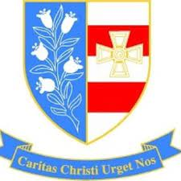
A Level English Language
Bridging Course
Name:

Congratulations on choosing A Level English Language as one of your courses! You’re about to embark on what will hopefully be a rewarding and fascinating journey of discovery into the English Language, supported by an enthusiastic and knowledgeable department. We look forward to classes welcoming you in September. Please bring this work with you to your first lesson.
As part of your studies of English Language, you will build on the knowledge about language you have been developing since you first started learning to read and write and acquiring spoken skills. The tasks in this booklet are designed to refresh some of what you already know and to begin your learning journey towards a comprehensive understanding of aspects such as:
- grammar (the structure of the language)
- lexis (vocabulary) and semantics (meaning)
- pragmatics (how language is used in various contexts)
- language and society

As well as this booklet, in September you will also need:
2 x A4 Lever Arch files
2 x packs of A4 lined paper
2 x packs of file dividers
Highlighters / stationery / post-its

As a way of getting yourself ready for in-depth study of the subject, try to become more aware of the language in use around you. Some ideas are below:
- Is your use of spoken language noticeably different depending on your audience? How does it differ when talking to: close friends; parents or carers; grandparents; people you don’t know?
- Do people of different genders in your life use language differently? If so, what differences can you notice?
- Which regional accents are most prevalent on TV? Do any accents seem associated with particular types of programme?
- If you have any babies or small children in your family, what observations can you make about how they acquire and use language?
Task 1: Seneca bridging work
Having enrolled on the A Level course, you are invited to join the Seneca class on the link below:
https://app.senecalearning.com/dashboard/class/piy79m65gd/assignments/assignment/952844bd-64cf-4f00-bcd2-b6c9856689d3
Class code: piy79m65gd
When you join the class, you will find that you have been assigned two courses: the first, a refresher of your GCSE knowledge and the second, a taster of some new areas relevant to your A Level studies. The tasks can be completed online, don’t all have to be done at once and your scores will be recorded immediately. Don’t worry about this aspect though; the whole purpose of bridging is to give you a flavour of what you’re going to learn in person from September. No one knows how to drive a car until they’re taught and it’s the same with the acquisition of language knowledge and skills!

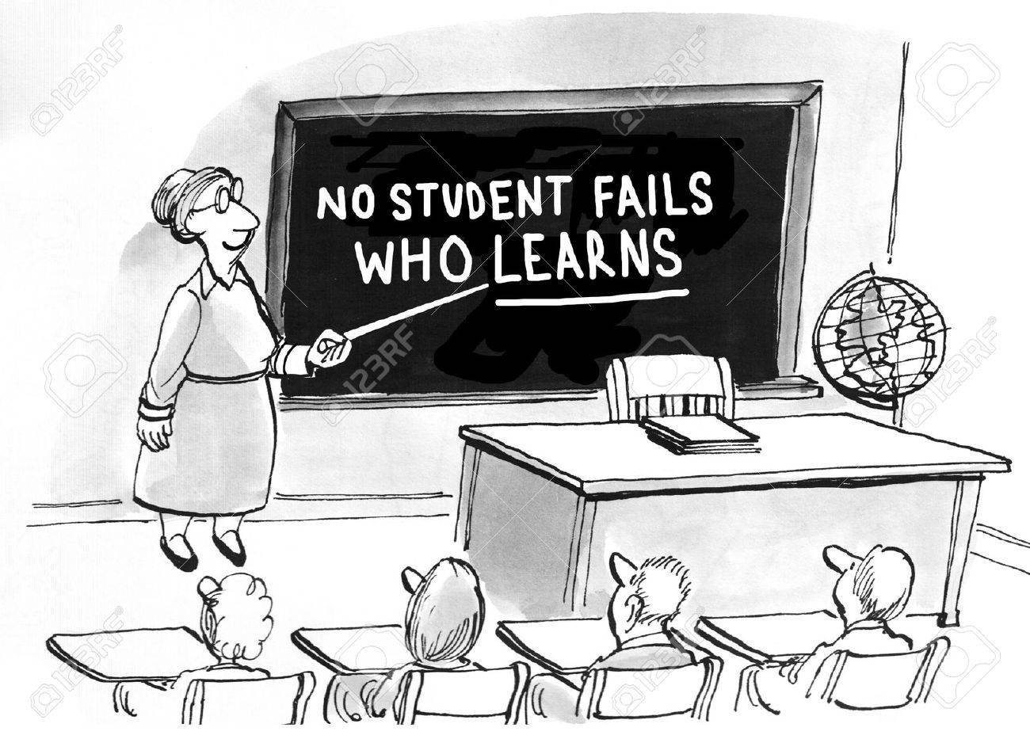

Task 2: Meanings and representations
On Paper 1 of A Level, you will be required to read two texts and comment on how the producers of the texts present their viewpoint and achieve their purpose through their language choices. This task will give you some practice at doing this. Don’t worry about not having the correct terminology through which to express your ideas, as again this is something that you will learn in time.
Text 1: read the text carefully and then complete the questions below (notes are sufficient).

Oi, you – yes, youse lot – I’m talking to you, y’all
Rachel Braier

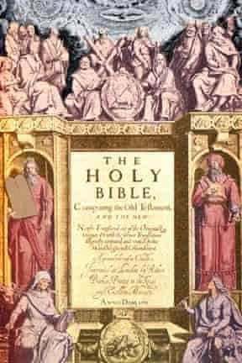
Although some regional dialects retain the distinction, most English speakers have to make do with using ‘you’ to mean one person or many

In the King James Bible, when Jesus said “Marvel not that I said unto thee” (John 3:7) he was talking to one person, and when he added “Ye must be born again” he was talking to everyone. Photograph: Alamy

No 99 on my list of “things that shouldn’t bother me, but they do” is the fact that the English language has no second person plural pronoun (SPPP) and that “you” is used interchangeably.
Before you (plural, hopefully) dismiss this as a #middleclassproblem, let me assure you that it is not. It is a genuine linguistic affliction that causes confusion and imbues our everyday speech with a clumsiness and imprecision that can be maddening.
I am not the first person to get that this is a problem. Language geeks are venting their spleen all over the world wide web about this very issue. Now I believe a solution is needed once and for all.
Standard Modern English is unusual in that it doesn’t have the distinction. In many European languages, there are even lines drawn between the formal and informal SPPP. In Spanish, for example, it’s tu when you’re having a one-to-one with your mate and vosotros when chatting to your amigos; usted when talking to your bank manager, but ustedes for a gaggle of them.
We used to distinguish between thou and thee (singular); ye and you (plural). Many regional dialects still retain these archaic distinctions in their everyday speech, including those in parts of Yorkshire, Cumbria and Lincolnshire.
So when and how did “you” become a catch-all pronoun?
For an expert opinion, I consulted Dr Mel Evans, a lecturer in English language at the University of Birmingham. She said: “You became associated with ‘polite society’ from the end of Elizabeth I’s reign. It was this same ‘polite society’ that was largely responsible for the codification of Standard English in the following centuries, and it was their variety of English that was fixed and prescribed and taught in schools.”
The distinguished 20th-century linguist Otto Jespersen believed that the loss of the SPPP was rather a good thing, noting that English was the only European language to get rid of what he called a “useless distinction”.
Now I’m going to hazard a guess and say that Jesperson never had to mobilise two under-10s on the school run, as I have to every morning. If he did, I’m sure that he wouldn’t be championing this linguistic nuance and ambiguity. Let me assure you that nuance and ambiguity, where the school run is concerned, can only end with you crying into a bottle of gin by 10am.
“Get your shoes on, you – no, not you, I can see you’ve already got yours on – you, yes you, the pair of you, hurry up.”
Now do you see why I am so desperate for that vital bit of clarity that an SPPP would give me? Standard British English doesn’t provide the answer, but in the southern states of the US, they’ve got around it by using “y’all” (you all).
Here, the nearest we have to a solution is “you lot”, but it’s difficult to use without sounding as if you’re about to punch the recipients in the face and it only really works if you preface it with an “oi”.
In my native Essex and on Merseyside, you’re most likely to hear “youse”, while Geordies and Glaswegians prefer “yiz”.
My husband, who is infinitely posher than me, winces whenever someone says “youse”; but I think the yousers have got it right. Why should we make do with this linguistic ambiguity and persist with a grammatical anomaly?
When Shakespeare, Milton or Dickens didn’t have a word to describe something, they invented one, and our language is all the richer and more beautiful for it. So instead of lauding those who put up with the limitations of Standard English, let’s back-slap those who have broken free of this collective inertia and found their own solution.
However, while I’m all for regional variations and dialects, I feel that we do need something set in stone on this one. So please, whoever it is who’s in charge of Standard English, youse lot really need to sort it out.
https://www.theguardian.com/media/mind-your-language/2015/jun/05/oi-you-yes-youse-lot-im-talking-to-you-yall
Summarise the content of the article in no more than 100 words:

What do you think was the writer’s purpose in producing this piece? Include some evidence to support your ideas.

How does the writer create a relationship with the reader? Are they presenting themselves as more knowledgeable than, the same as, or different to their audience? Include some evidence to support your ideas.

What is YOUR opinion on this topic? Are there any linguistic issues which annoy or confuse you?

Text 2: read the text carefully and then complete the questions below (notes are sufficient).

As reformers vote to make it easier for children to learn English... These nu, sili speling rools tayk the biskit
By CRAIG BROWN FOR THE DAILY MAIL

Howz yor speling? An organisation known as the International English Spelling Congress has just voted in favour, or favor, of major reform.
Apparently, English takes up to three years longer to master than other languages, and the peculiarities of our spelling system are at least partly to blame.
The congress is concerned that far too many English words don’t sound the way they are spelt, or, indeed, spelled. Traditional Spelling Revised, or TSR, aims to get rid of silent letters such as ‘w’ in wrong.
If they have their way, rong will soon be right, rite will no longer be rong, and illogical spellings such as colonel, biscuit, yacht, daughter, parliament and knife will all be simplified.
With this in mind, it can’t be long before they vote to change their name to the Intunashnal Speling Congris.
Perhaps they might even be persuaded to open their annual conference with a medley of Slade’s greatest hits — Cum On Feel The Noize, Coz I Luv You, Look Wot You Dun.
Those who find spelling easy tend to pooh-pooh the idea that it should be simplified. They prefer to equate poor spelling with stupidity. How they rejoiced in 2013 when Donald Trump bragged that he’d just been named the third most envied man in America, tweeting that ‘the small group of haters and losers must be nauseas’.
Back in 1992, the target of their derision had been U.S. vice president Dan Quayle, who sent an official Christmas card declaring America to be ‘the beakon of hope for the world’. Later, poor old Quayle was filmed urging a schoolboy to change his spelling of ‘potato’ to ‘potatoe’.
Conservatives giggled when Tony Blair spelt the word ‘tomorrow’ wrong three times in the course of a single letter to a by-election candidate. In the same way, Left-wingers rejoiced at the revelation that the note written by Margaret Thatcher for her famous 1979 election victory speech included the word ‘dispair’.
Speaking for myself, I couldn’t help smiling when I heard that pompous know-all Jacob Rees-Mogg had published a book in which he referred to ‘Pontius Pilot’.
But, then again, poor spellers have long been a feature of politics. The 19th-century prime minister Lord Palmerston once gave a spelling test to his Cabinet, dictating this tricky sentence for them to copy out: ‘It is disagreeable to witness the embarrassment of a harassed pedlar gauging the symmetry of a peeled potato.’ Not one of them managed to spell every word correctly.
On the other hand, poor spellers are in excellent company. After all, Jane Austen titled her first book, written when she was 15 years old, Love And Freindship.
The first draft of The Great Gatsby contained hundreds of spelling mistakes, among them ‘chaoticly’ for ‘chaotically’, ‘ecceptionally’ for ‘exceptionally’, and ‘yatch’ for ‘yacht’. The novel’s author, F. Scott Fitzgerald, often addressed his best friend Ernest Hemingway as ‘Ernest Hemmingway’ or even ‘Earnest Hemmingway’.
Surnames are often tricky. In 1965, the Queen wrote Noel Coward a letter: ‘Could you not come down to Sandringham for the night of July 20th — when a famous old Russian cellist (I can’t spell him) is playing in one of our lovely old churches?’
And place names, too, can be a minefield. Did Zbigniew Brzezinski ever visit Kyrgyzstan?
Interestingly, poor spellers often over-compensate by adding one or two extra letters to a word. The late poet laureate Ted Hughes favoured ‘develope’, ‘mentionned’, ‘daffodill’ and ‘alltogether’.
Before the advent of the printing press, how you spelt a word was largely up to you. It was not until 1500, as printed books grew more common, that spelling became increasingly standardised.
And as spelling became more uniform, demands for its simplification increased. Rationalists have always been enraged by the illogicality of English spelling.
George Bernard Shaw highlighted the disconnect between letters and sounds by pointing out that the word ‘fish’ might be better spelled ‘ghoti’ — after all, the ‘gh’ from ‘enough’ sounds like an ‘f’, the ‘o’ in ‘women’ sounds like an ‘i’, and the ‘ti’ in ‘nation’ sounds like ‘sh’.
How complicated it all is! The International English Spelling Congress certinly has a mountin to clim. It all reminds me of a joke we used to tell in the school playground. ‘Floccinaucinihilipilification is a very hard word to spell. Can you spell it?’
And the answer, of course, is ‘it’.
https://www.dailymail.co.uk/debate/article-9489153/Reformers-vote-make-easier-learn-English-nu-sili-speling-rools-tayk-biskit.html

Summarise the content of the article in no more than 100 words:

What do you think was the writer’s purpose in producing this piece? Include some evidence to support your ideas.

How does the writer create a relationship with the reader? Are they presenting themselves as more knowledgeable than, the same as, or different to their audience? Include some evidence to support your ideas.

What is YOUR opinion on this topic? Do you think that the English spelling system needs to be reformed?

Task 3: Language Diversity
For Paper 2, your studies will cover a wide range of SOCIOLINGUISTICS topics, that is how social factors such as gender, class, ethnicity and age affect language use. Read each of the sets of statements below and make some notes in answer to the questions alongside. They will form the basis of some discussion in September.

Men can’t talk to women properly. Women just chat, nag and gossip anyway. | Do men and women use different words, styles and structures in conversation?  Is it possible to generalise about how different genders use language?  Does language represent men and women in different ways? Think of the connotations of words such as ‘male nurse’, ‘master/mistress’, and ‘fireman’.

Gay>happy>homosexual>stupid  C u l8r :)  That man is vertically challenged and works as a sanitation engineer; his significant other is a homemaker. | Why and how do some words change their meaning over time? Can a word ever have a single, definite meaning and who would make that decision?  How are new technologies affecting the way that we communicate with each other? Do these technologies have any impact on the way we write or talk?  What is political correctness and is it necessary? Is it possible to control the way that language is used? Should people have the right to write and speak any way that they like?

We have really everything in common with America nowadays, except, of course, the language.  Oscar Wilde  Britain is a very distinct country from the US. Not better, not worse, different. And long live that difference. That means maintaining the integrity of our own gloriously nuanced, subtle and supple version - the original version - of the English language. Matthew Engel | What Americanisms are you aware of in the English Language? Is there any harm in using them instead of the British English alternative?  English is statistically the most globally dominant language, used in many nations across the world as a first or second language. Who should make decisions about its usage?

If you have any questions about the course or the activities in this booklet, email:

soconnor@stjosephs.uk.net
mcewene@stjosephs.uk.net
kerrm@stjosephs.uk.net

