Name:
I chose Business because….

The purposes of this Bridging Course are as follows:
- To allow you to be familiar with the essential ideas behind the subject
- To become familiar with the language used in the subject
- To help you to understand what the subject is and what it is not
It is advisable that you consult the Internet. You will need to be careful about which sites you use. Some are not rigorous and will give you superficial and incorrect answers. This is a topic which will be covered in the first week.
Failure to complete the course will mean:
- A poorer appreciation of the subject you will study
- Lack of familiarity with the topics to be covered.

You need to complete and return the course to your class teacher during the first week of Year 12
Task 1 – Marketing
This task links to the Unit 2 Marketing Campaign exam that you will sit in May/June 2023.
You have been asked by the Managing Director of a sportswear brand called “Decreal Gear” to produce a marketing campaign in order to help them increase sales. You have been given a budget of £20,000
Some information is given about the business below.
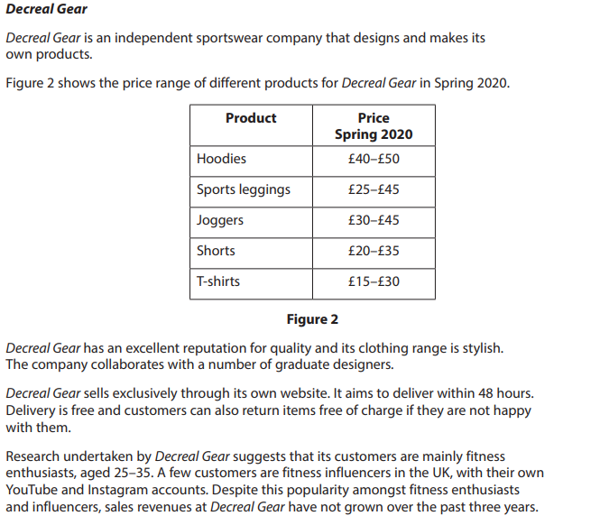

You should carry out extra research, for example. Looking at competitors’ products and prices. What is their “market share” and how loyal are customers? What are the latest trends? What influencers the purchasing decisions of customers?

You should complete this task either by using PowerPoint or on paper. You should discuss “The 4 P’s” – Product, Price, Place, Promotion.
What products should they sell? Why? At what price? Why? Where can customers access them? How will they be promoted?

Task 2 Quick Maths - As part of the Unit 3 exam you will be required to use a calculator to do mathematical equations like the ones below
1. | Josephs profit for January was £1200, this increased by 15% in February. What is Februarys profit?

2. | Sophie had 50 students at her football coaching course, she now has improved that to 75 students. What is the % increase?

3. | Emma sells her cakes for £1.25, how many does she need to sell to reach her target revenue of £817.50?

4. | James sells 7 basketballs a week, how many does he sell in a year?

5. | Tom needs to workout his break even point., Using the information and the formula below to work it out for him. Fixed costs 40,000. Selling price £12, cost per unit £2.
Fixed Costs/selling – cost per unit
Task 3 - What do you understand about the following terms? Write any notes or an explanation in the box provided
Bankruptcy
Credit Rating
Debt
Mortgage
Pay day loan
Credit card

Task 4 - Using McDonalds as a reference, answer the questions below

Why is it important for them to set the correct price?

Why is it important to develop new products?

Explain how McDonalds stand out from their competitors, use more than one example.

Task 5. PESTLE Analysis
Pick a multinational Business and carry out a PESTLE analysis, how is that business impacted by these factors?
Chosen Business
P – Political
E – Economical
S – Social
T – Technological
L – Legal
E – Environmental/Ethical

