GCSE English Language Paper 1: Explorations in creative reading and writing
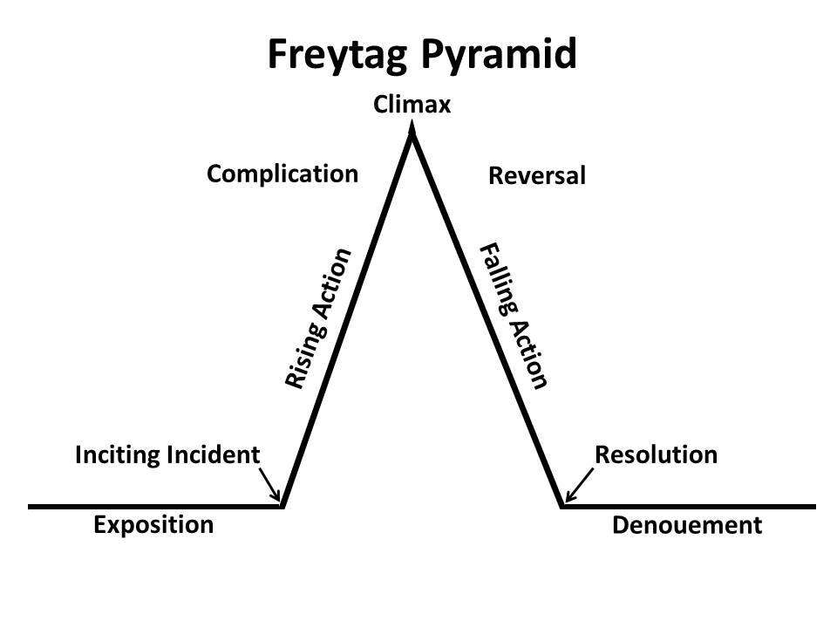
As well as full stops, capital letters, commas and apostrophes, learn how to use the following pieces of punctuation:
colon | : | A colon is usually used to introduce an important piece of text like an explanation or a definition.
semi-colon | ; | A semi-colon is usually used to link two full sentences for a specific reason, often to show they are connected.
ellipsis | ... | An ellipsis (three dots) indicates that part of the text has been intentionally been left out. It can be used to add tension in a text.
brackets | ( ) | Brackets are curved lines used to separate  explanations or additional information within a sentence.
dash | – | A dash is used to link two sentences or clauses together. It can also make the reader pause or add extra information.
hyphen | - | A hyphen is used between parts of a compound word or name. It is also used to split a word by syllables to fit on a line of text.

Order | Timings/marks | Writing frames and reminders
 | 15 minutes | Read the source and questions and annotate the text in detail looking at language and structure
Answer question 1 | 5 minutes  4 marks | List four things:  Only write about what is specifically named in the question. Write four sentences starting with the name of the thing and/person named in the question.
Answer question 2 | 10 minutes  8 marks | How does the writer use language – aim to write 3 paragraphs  The writer uses... [name method]… For example [use quotation]… This suggests/implies/creates an atmosphere of…reinforces a sense of…highlights…
Answer question 3 | 10 minutes  8 marks | How is the text structured to interest you as a reader – aim to write 3 paragraphs  Think about pace/climax/perspective/zooming in and zooming out/sentence length and types  At the beginning the writer focuses my attention on… For example [use quotation]… This interests the reader because… Then, the writer shifts my attention to…. For example [use quotation]… This interests the reader because… Finally at the end the writer shifts my attention to…. For example [use quotation]… This interests the reader because…
Answer question 4  Answer question 5 | 20 minutes  20 marks  45 minutes  40 marks | To what extent do you agree with the statement – aim to write 4 paragraphs  Make sure you understand the statement. Find examples and methods in the text that create the same effect as suggested in the statement.  I agree when the statement says… This is because the writer uses [name method]… For example [use quotation]… This suggests/implies/creates an atmosphere of…reinforces a sense of…highlights…  Write in paragraphs – aim to write 5 paragraphs  Make sure you plan  Use impressive vocabulary all the way through and use a range of techniques like simile, metaphor, personification and alliteration  Vary your sentence lengths  Use accurate and varied punctuation
Language toolkit. Identify and use these methods:
- Alliteration
- Sibilance
- Adjective
- Verb
- Noun
- Adverb
- Simile
- Metaphor
- Personification
- Onomatopoeia
- Imagery
- Pathetic fallacy
- Juxtaposition
- Foreshadowing

Structure toolkit. Identify and use these methods:
- How the extract begins (and why)
- How the extract ends (and why)
- Turning points / shifts in focus (and why)
- Narrative perspective
- Flashback
- Flash-forward
- Foreshadowing
- Zoom in/zoom out
- Internal thoughts
- Pace

Fictional texts terminology:
- Narrator – first person/third person/limited narrator/biased narrator
- Protagonist
- Antagonist
- Setting
- Characterisation
- Dialogue
- Plot

Tip!
When analysing quotations, think about the connotations of certain words and the effects of these connotations.

Question 5: paragraphing and structure
- Change paragraphs when you come to a change in time/person/topic/place
- To signify a change in mood or emotion
- Link your opening to your ending

