Month of Miles

Dear Parent/Carer

All of our lives have changed dramatically since COVID 19. We’ve missed our school life, sports centres are closed, all events have been cancelled and families and friends have been separated from each other for many months.

We want to bring our community together again, have fun, get fit and raise funds for some wonderful local charities who need our support now more than ever.

During MONTH OF MILES we invite you to join family, friends, staff and members of your community, walking, running or cycling their way to the 13 September 2020 - the day our famous Great North Run 2020 should have taken place.

You set your target from the choice below, register your place then prepare for a flying start on 13 August 2020!

You can complete your challenge from 13 August to 13 September 2020.

Don’t forget to fundraise for your brilliant local charities by asking friends and family to donate at: https://paypal.me/BishopChadwickdonate?locale.x=en_GB

Cycle
- Individual minimum 24 miles.
    - Family minimum of 48 miles
Then in 12 mile blocks (weeks of lockdown).

Run
    - Individual minimum of 13 miles (GNR half marathon).
    - Family minimum of 26 miles.
Then in 13 mile blocks.

Walk
      - Individual minimum 6 miles (Blaydon Race).
      - Family minimum 24 miles.
Then in 6 mile blocks.

Registration fee:
£10 per adult (18+)
£5 per child/concession
£25 per family (up to 5 members)
All participants must register. Those paying the registration fee will receive a T shirt and certificate upon completion of their challenge. If you are unable to or choose not to pay the registration fee you will receive a certificate upon completion of your challenge.

For registration and payment please visit your ParentPay login.

For registration only please email office@stjosephs.uk.net .

Please make sure you register between Friday 10 July 2020 –Thursday 16 July 2020 to secure your place.

The Headteachers of all schools in our Trust and partner schools have selected the following local charities to support. These charities do amazing work across the North East but specifically in South Tyneside, Sunderland, and East Durham.

Yours sincerely

Mr P Mitchell
Head of School

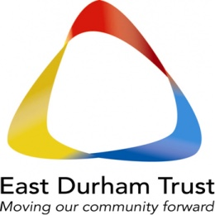
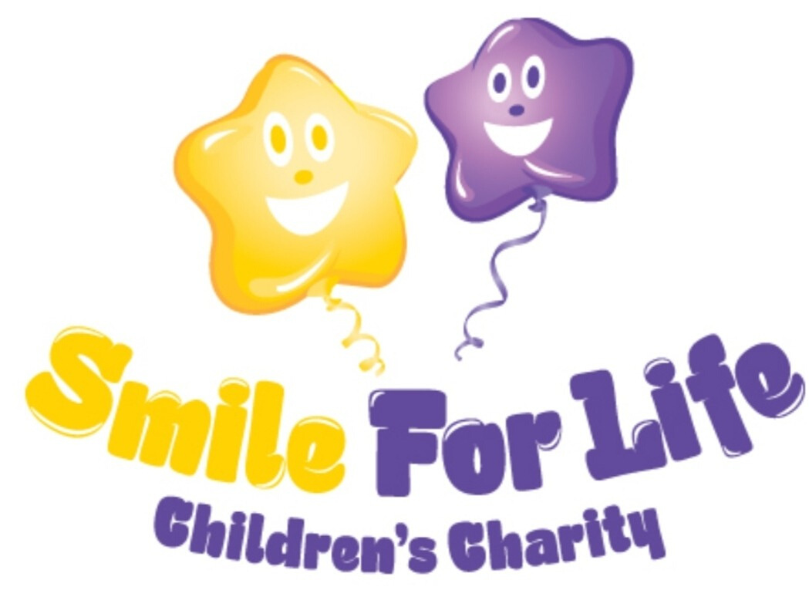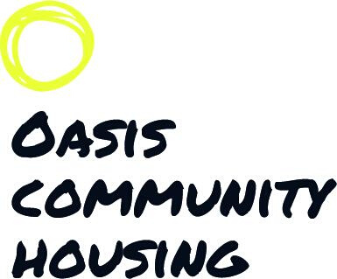

Ready……..Steady…..…Go!!!!

