Home Study – Top Tips for Students
Create a schedule each day
Don’t worry if you cannot stick to your school timetable. This is just a recommendation to help you get organised. You should work for about 3 hours each day. This should include some exercise!

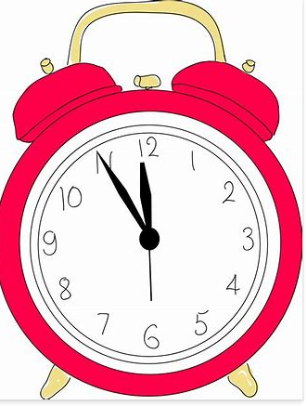 | Work out when you will be able to do the work  You may only have IT access at a certain time of day, and you may be sharing devices. If this is the case, do your work when you can.
Which work should you complete first?
The work from your subject teachers should be completed first.
There are lots of other optional activities that you can use to give you a balance to your learning. These include the #stjosephs20 challenges, challenges from your subject teachers and our weekly St Joseph’s Journal.
Well-being tasks are also available each day on Google Classroom, for you to use whenever you like.
When you have finished your work
It is likely you may finish the work set quickly – that is fine! Working from home is a different routine. Just try to complete the work to the best of your ability. If you finish your work early or want more work, complete an activity where you review or practise prior or new learning, for example go back over your work and make flashcards of key words and definitions, make a graphic organiser or do some self-quizzing. Alternatively, do wider learning around your subject (e.g. reading or watch a film or documentary).

Do one more thing
Later in the day, go and sit with a family member with your schedule for the day. Get them to ask you questions about your work for each subject to make you think about and remember what you learnt. You are more likely to get the work into your long-term memory this way and by saying it out loud. If you cannot remember, go back over the work and write it on a revision card to prompt you for next time.

What should you do if you need help?
If you are finding a task tricky, or you don’t understand the instructions for a task, you can message your subject teachers on Google Classroom.
You can also ask for help using the Home Study Help email address – homestudyhelp@stjosephs.uk.net

