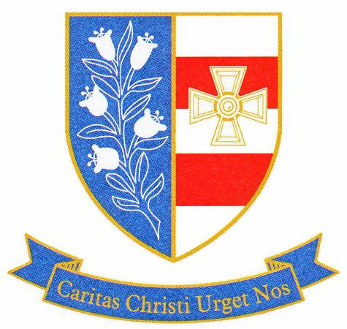

St Joseph's Catholic Academy

A Leading Edge Technology & Applied Learning College
Mill Lane, Hebburn, Tyne and Wear, NE31 2ET
Executive Headteacher: Brendan Tapping
Telephone: 0191 428 2700

Email: Office@stjosephs.uk.net Acting Headteacher: Mr P Mitchell
Web: www.stjosephs.uk.net Chair of Directors: Mrs G Kilgour
Fax: 0191 428 4053

10th March 2020
The Feast of St. Joseph: Random Acts of Kindness Day
Dear parent/carer,
On Thursday 19th March we will be celebrating as a community the feast of our patron saint, St. Joseph. As part of these celebrations we will be hosting a ‘Random Acts of Kindness Day’ in which students and staff will be encouraged to complete Random Acts of Kindness throughout the day.
Random Acts of Kindness are a fun and exciting way to live out our Christian mission to ‘love thy neighbour’. Acts of kindness can range from holding a door open for someone, sharing a smile or complimenting someone, through to completing some charity work or social action. It would be fantastic if you can discuss some ideas with your son/daughter in advance of this day about what they would like to do on this day. Sometimes even the smallest act of kindness can have the most profound impact on others in our community.
As a school we are deeply committed to the values of Faith, Learning and Respect, three values that were integral to Saint Joseph himself. We hope that this day will encourage students to develop each of these values further. We are hoping with your support that St. Joseph’s Day and our Random Acts of Kindness day will provide an opportunity to celebrate the caring nature of our students. If you do not currently follow our Facebook page, it can be found by searching for St Joseph’s Catholic Academy or @stjosephsca. As well as daily updates during St. Joseph’s Day our Facebook page allows followers to be informed of important dates as well as news of events taking place in school throughout the year.
God bless and thank you for your support.
Andrew Young
Curriculum Leader for Religious Studies

