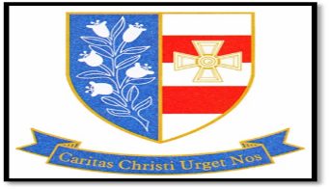
St Joseph’s Catholic Academy
Mill Lane
Hebburn
Tyne and Wear
NE31 2ET
Tel: 0191 4282700
Executive Headteacher: Mr T B Tapping
Invigilator £9.36 per hour
Working hours will be variable depending on examination requirements.
St Joseph’s safeguards and protects its students and staff by being committed to respond in accordance with South Tyneside Council Child Protection Procedures. The successful candidate will be subject to an enhanced DBS check.
Application forms and further details are available on the school’s website to be returned to the school or office@stjosephs.uk.net .

