Work Experience Planning
During the summer term you will have the opportunity for a work experience week. This is your chance to experience the area of work you want to go into in the future.
There is however a lot of demand for work experience so it is essential that you start now to look for places you could go. Do some research about the local jobs market and area to find out which different employers and roles you could gain experience of. Then start to contact them- either by email, letter or telephone. Your tutors will be checking who you have been in contact with to ensure you are making the best effort to find the most suitable work experience.
When you contact someone, you can make a note of who you have been in touch with.
Company or business | Name of contact | Type of experience | Response?

Contacting Possible Placements
How do I start a conversation?
Once you have secured a placement using the site you may want to contact them to find out details. It can be daunting to think about contacting someone to talk about work experience. Most companies will have a contact email address on their website. Here is a sample email to start you off.
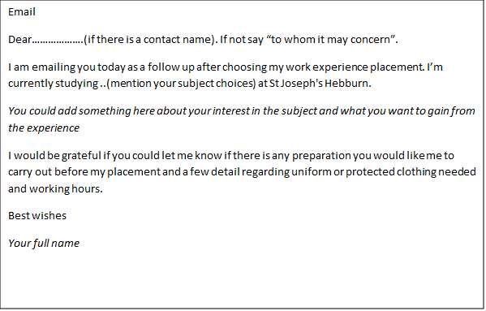
You may want to make a phone call. It is sometimes easier if you make some notes to prepare beforehand. Use the email outline to help you to make some notes to get the most out of your phone call.

